West Hall PTO Shirt Order Form
ORDER FORMS DUE BY: SEPTEMBER 20, 2019
Student Name: ________________________________________ Homeroom: ____________________________
Phone Number: _______________________________________ Paid by: (circle one) Cash or Check #________
Shirt #1 | $
Shirt #2 | $
Shirt #3 | $
Shirt #4 | $
Shirt #5 | $
Total | $
***Checks need to be made payable to WHMS PTO
Shirt Style | Youth Large -- Adult XL | Adult 2XL -- Adult 5XL
T-Shirt – Short Sleeve – Navy or Gray | $ 15.00 | $ 20.00
T-Shirt – Long Sleeve – Navy or Gray | $ 22.00 | $ 27.00
Hoodie Sweatshirt –  Navy or Gray | $ 30.00 | $ 35.00
Sweatshirt –  Navy or Gray | $ 30.00 | $ 35.00
Navy T-Shirt – This logo is available in the following shirt styles. Extended sizes add $5.00 per shirt

 | Youth | Adult Sizes |  |  |  | Add $2.50
 | L | S | M | L | XL | 2XL | 3XL | 4XL | 5XL
T-Shirt-Short
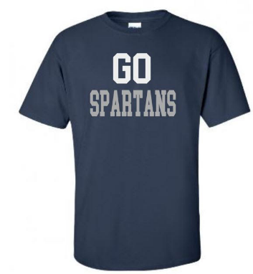
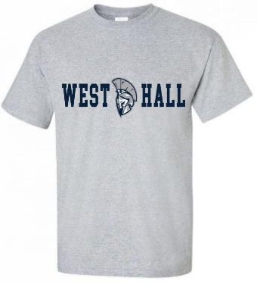
Grey T-Shirt – This logo is available in the following shirt styles. Extended sizes add $5.00 per shirt
 | Youth | Adult Sizes |  |  |  | Add $2.50
 | L | S | M | L | XL | 2XL | 3XL | 4XL | 5XL
T-Shirt-Short

 | Youth | Adult Sizes |  |  |  | Add $2.50
 | L | S | M | L | XL | 2XL | 3XL | 4XL | 5XL
Hoodie –
Gray or Navy
Long Sleeve Shirt –
Gray or Navy
Sweatshirt –
Gray or Navy

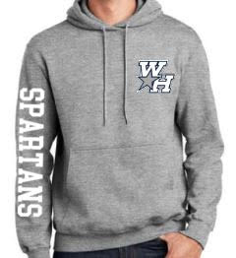
Navy or Gray Hoodie, Long Sleeve T-Shirt & Sweatshirt – Extended sizes add $5.00 per shirt

